Task on CloudTrail & CloudWatch
1. Enable CloudTrail monitoring and store the events in S3 and CloudWatch log events.
Objective:
To enable AWS CloudTrail monitoring and configure it to store API activity logs in an Amazon S3 bucket and Amazon CloudWatch Logs.

Prerequisites:
- AWS Account
- IAM user with permissions:
  - CloudTrailFullAccess
  - AmazonS3FullAccess
  - CloudWatchLogsFullAccess
  - IAMFullAccess (required for creating the CloudTrail service role if needed)
Step 1: Log in to AWS Management Console and create an S3 Bucket
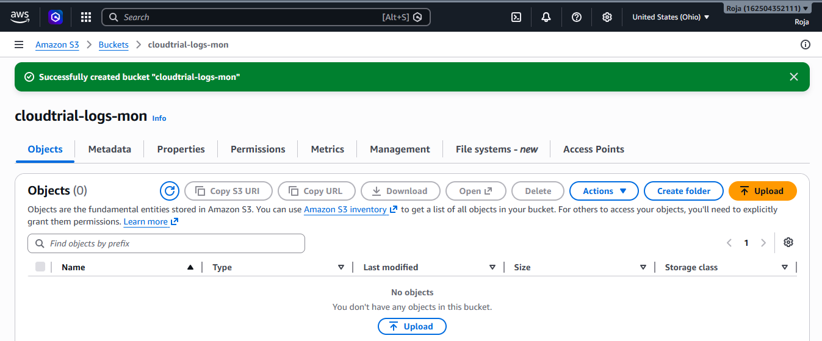
Step 2: Open CloudTrail, create trial and Configure trial
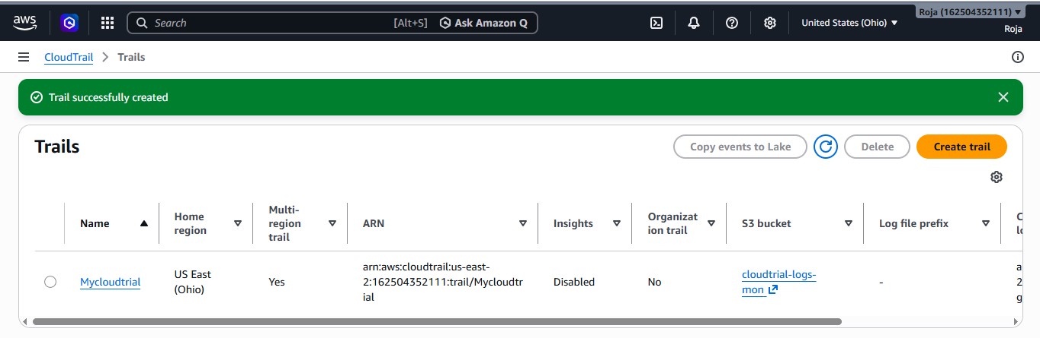
Step 3: Generate CloudTrail Events
To generate activity:
- Open Amazon EC2.
- Click Instances.
- Start or Stop an EC2 instance.
- These actions generate CloudTrail events.
Step 4: Verify logs in s3
Open your bucket. You will see AWSlogs. Click on it as follows:
AWSLogs/
Account-ID/
CloudTrail/
Region/
Year/
Month/
Day/
123456789012_CloudTrail_ap-south-1_20260727T1030Z.json.gz
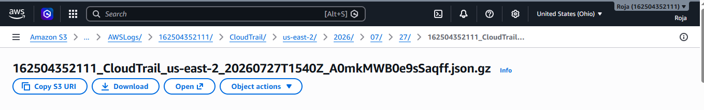

Step 5: Verify CloudWatch Logs
- Open CloudWatch.
- Select Logs → Log groups.
- Open CloudTrailLogs
- Open the latest log stream.
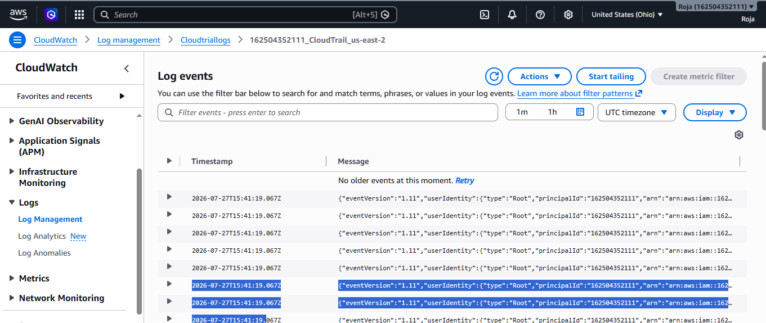

Step 6: Verify CloudTrail Event History
Open cloudTrial, click on Event History and verify

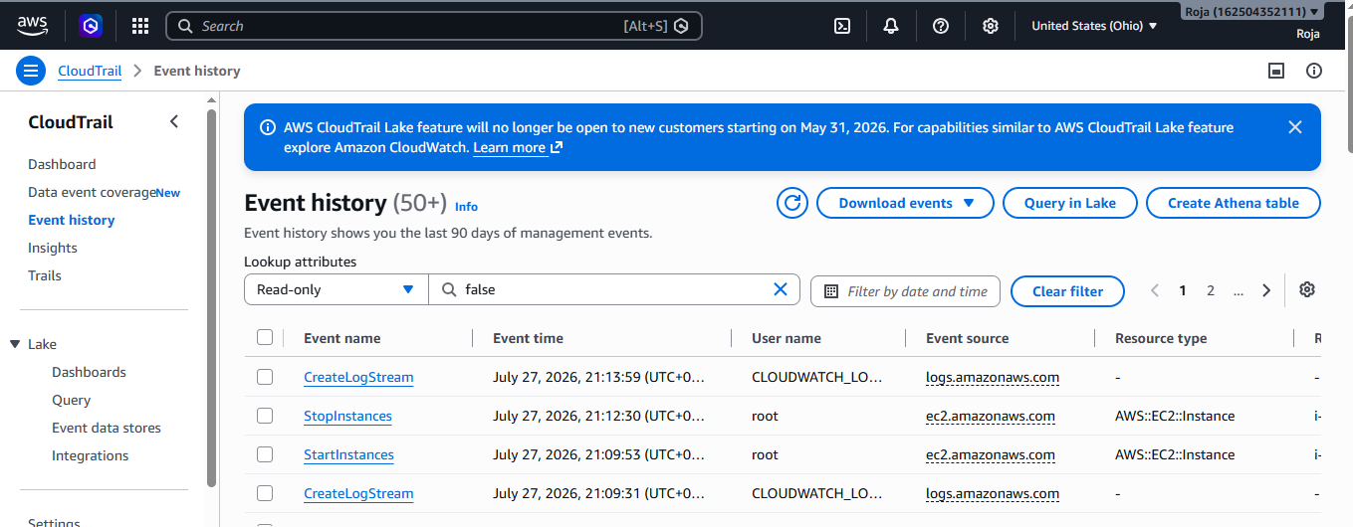

2. Enable SNS for CloudTrail to send alerts via email.

Objective:
To configure Amazon Simple Notification Service (SNS) with AWS CloudTrail so that email notifications are sent whenever CloudTrail log files are delivered.

Prerequisites:
- AWS Account
- IAM user with the following permissions:
  - CloudTrailFullAccess
  - AmazonSNSFullAccess
  - AmazonS3FullAccess
  - CloudWatchLogsFullAccess (optional if CloudWatch Logs is already configured)
- An active email address to receive notifications
Step 1: Log in to AWS Management Console and Create an SNS Topic
- Search for SNS in the AWS search bar.
- Open Amazon Simple Notification Service (SNS).
- From the left navigation pane, click Topics.
- Click Create topic.
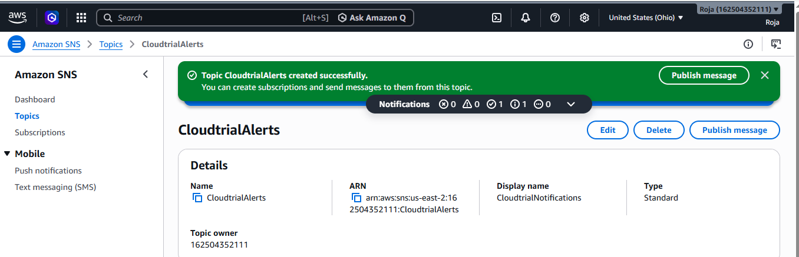

Step 2: Create an Email Subscription

- Open the CloudTrailAlerts topic.
- Click Create subscription.

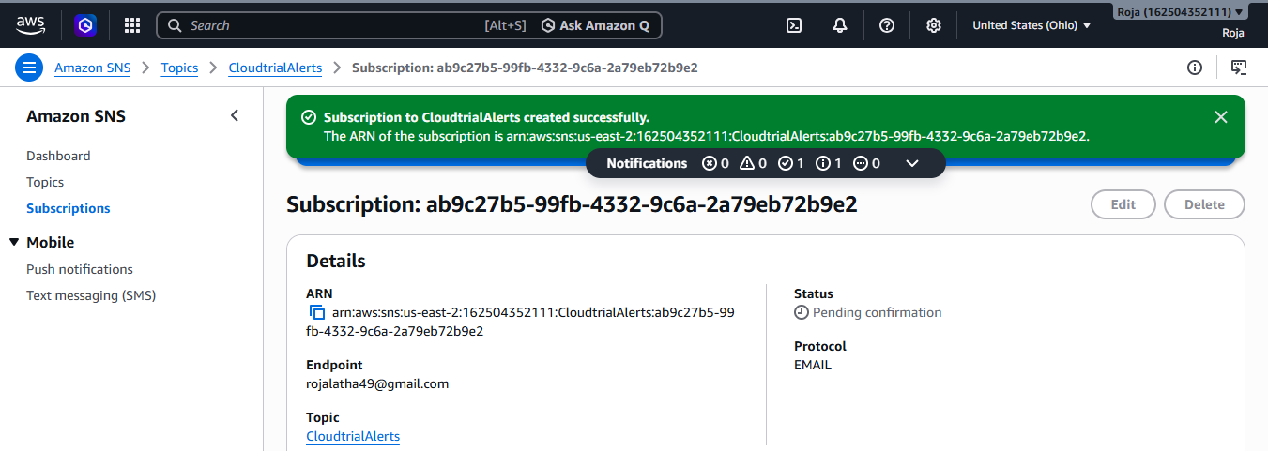

Step 3: Confirm the Email Subscription
- Open your email inbox.
- Find the email from AWS Notifications.
- Click Confirm subscription.
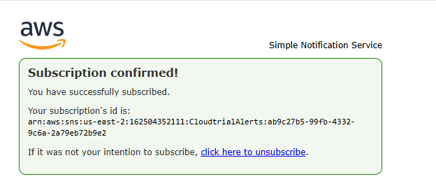

4. Verify that the subscription status changes to Confirmed in the SNS console.
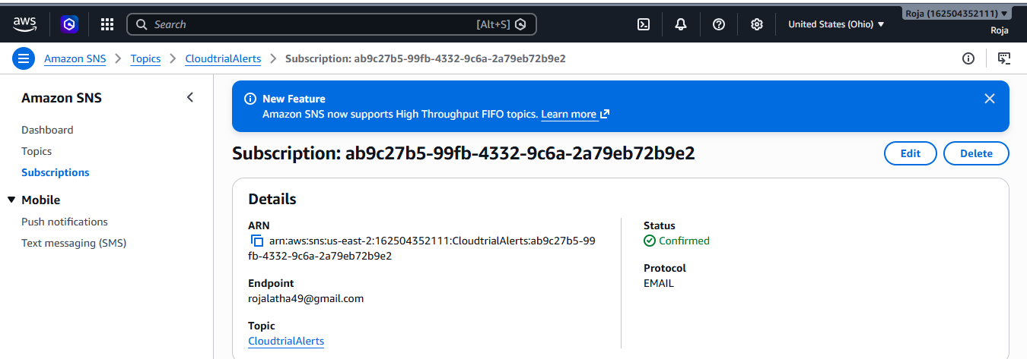

Step 4: Configure CloudTrail to Use SNS
- Search for CloudTrail.
- Open CloudTrail.
- Select your existing trail (or create a new one if needed).
- Click Edit.
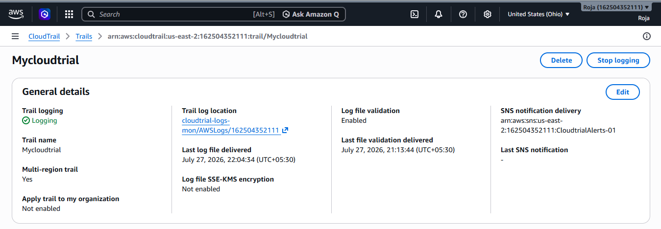

Step 5: Generate CloudTrail Activity
Perform any AWS action to generate CloudTrail logs, such as:
- Create an S3 bucket
- Upload a file to an S3 bucket
- Start or stop an EC2 instance

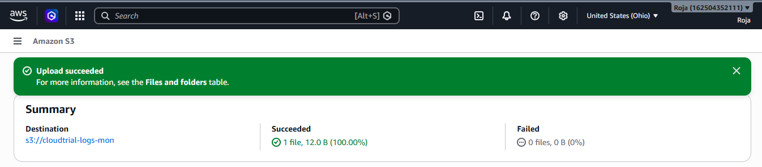
Step 6: Wait for CloudTrail Log Delivery
CloudTrail usually delivers log files to Amazon S3 within approximately 5–15 minutes after events occur.
If SNS log delivery notifications are enabled, an email notification is sent when a new log file is delivered.
Step 7: Verify the Email Notification
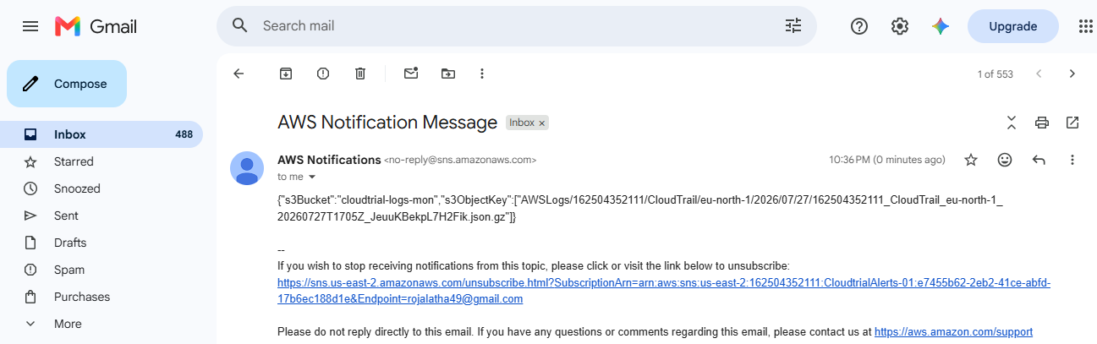

Step 8: Verify CloudTrail Logs

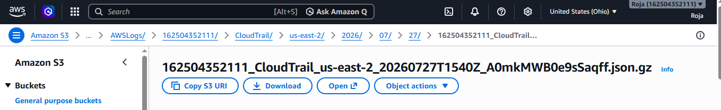

3. Configure CloudWatch monitoring and record the CPU utilization and other metrics of EC2.

Objective:
To configure Amazon CloudWatch monitoring for an Amazon EC2 instance and record CPU utilization and other performance metrics.

Prerequisites
- AWS Account
- IAM user with the following permissions:
  - CloudWatchFullAccess
  - AmazonEC2FullAccess
- One running Amazon EC2 instance
Step 1: Log in to AWS Management Console & Launch or Verify an EC2 Instance
1. Verify instance id, instance type and instance state and region.
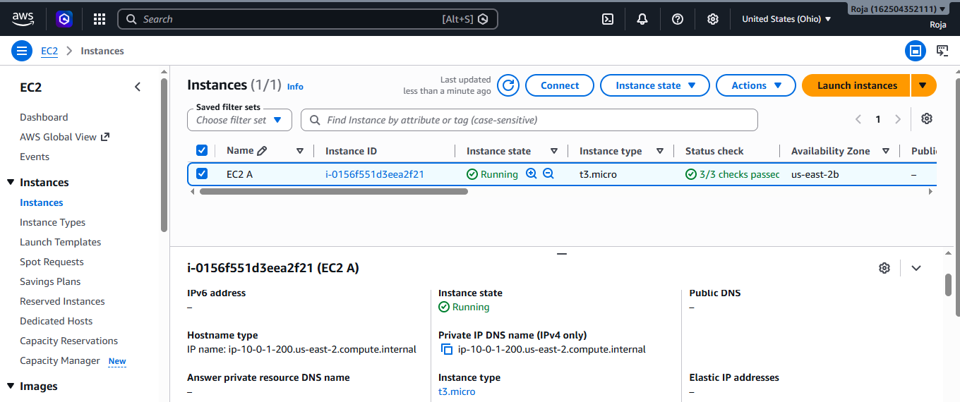

2. Open CloudWatch
- From the left navigation pane, select Metrics.
- Click All metrics.
- Locate EC2 Metrics
- Select EC2.
- Select Per-Instance Metrics.
- Find your EC2 instance.
- Select CPU Utilization.
- CloudWatch will display a graph.
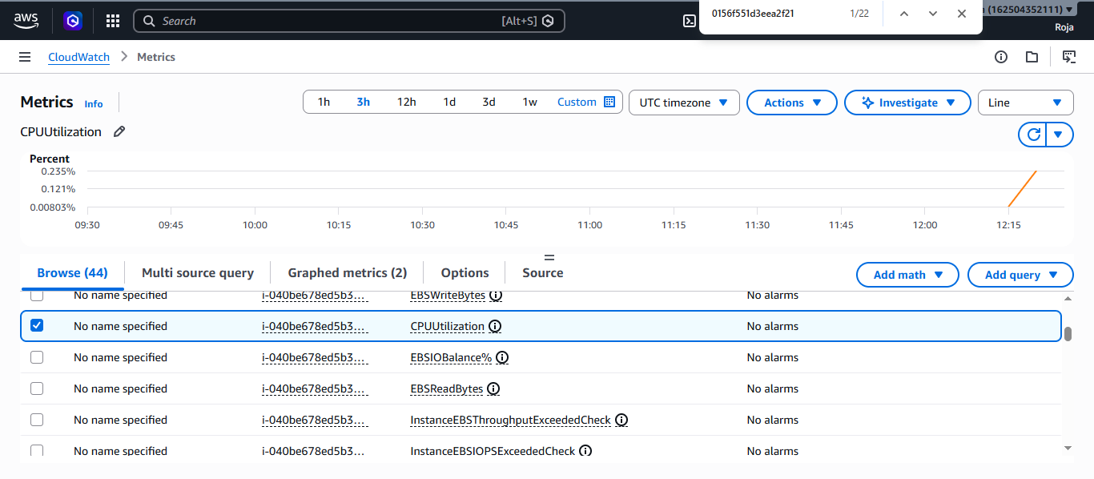
From the above graph CPU utilization is 0.235% for 3 hours
Graph for metric StatusCheckFailed_System for 3 hours:
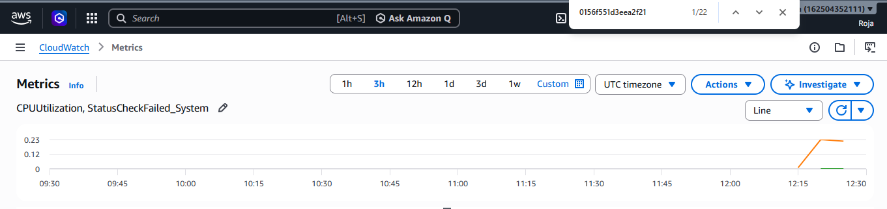

Graph for metric Networkout for 3hours:
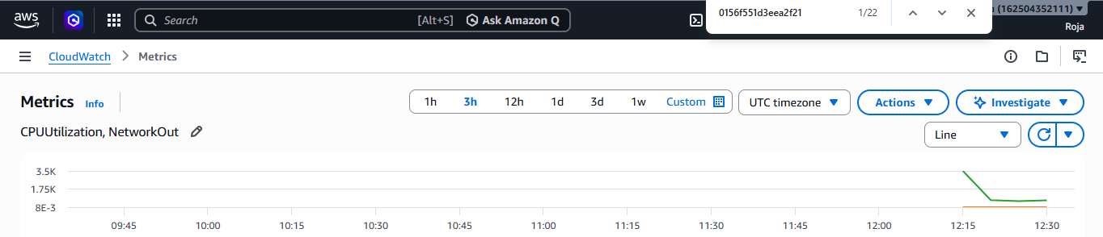

After changing the time range for last 1 hr CPU Utilization is 0.24%
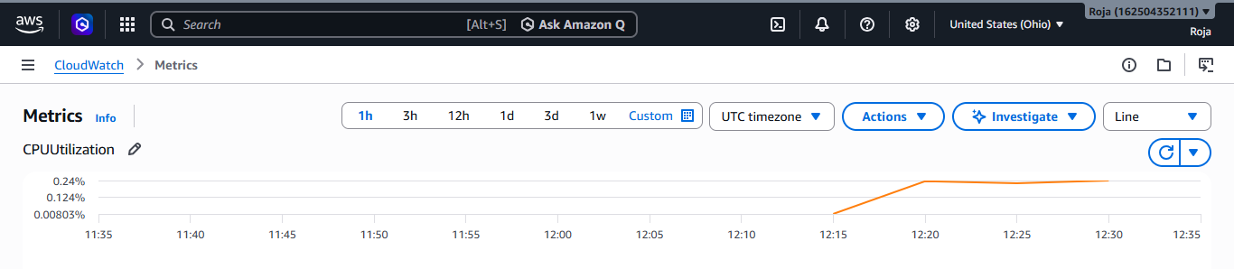

Generate CPU Activity
Connect to your EC2 instance using SSH or EC2 Instance Connect.
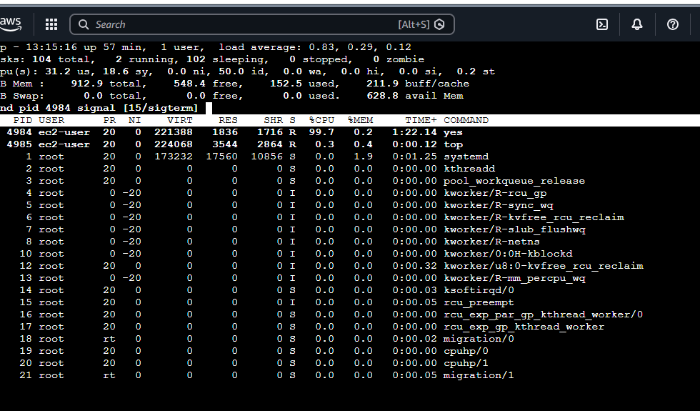
4. Create one alarm to send an alert to email if the CPU utilization is more than 70 percent.

Objective:
To create an Amazon CloudWatch alarm that sends an email notification through Amazon SNS whenever the CPU utilization of an EC2 instance exceeds 70%.
Prerequisites:
- AWS account
- Running EC2 instance
- CloudWatch access
- Amazon SNS access
- Valid email address
- EC2 instance publishing CPU metrics to CloudWatch

Step 1: Open CloudWatch and Create an SNS Topic

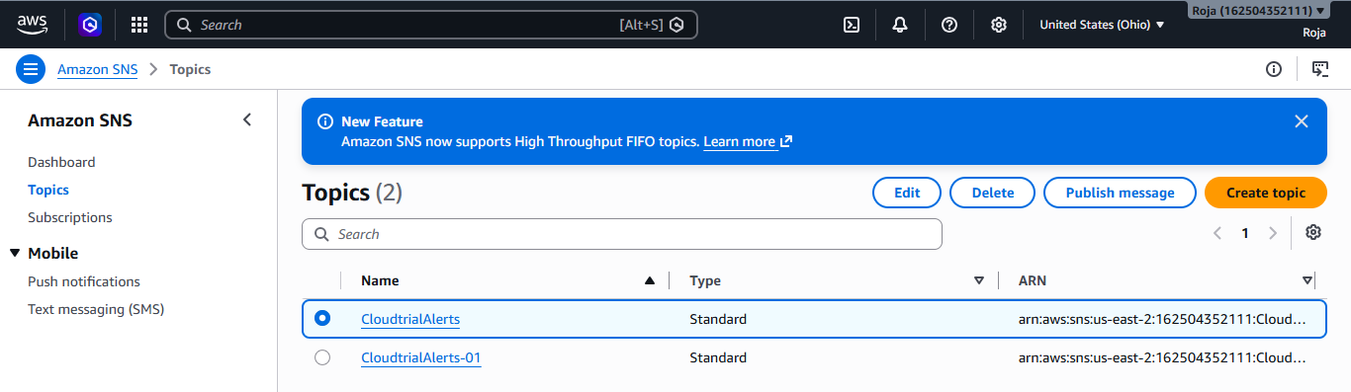

Step 2: Confirm the Email Subscription

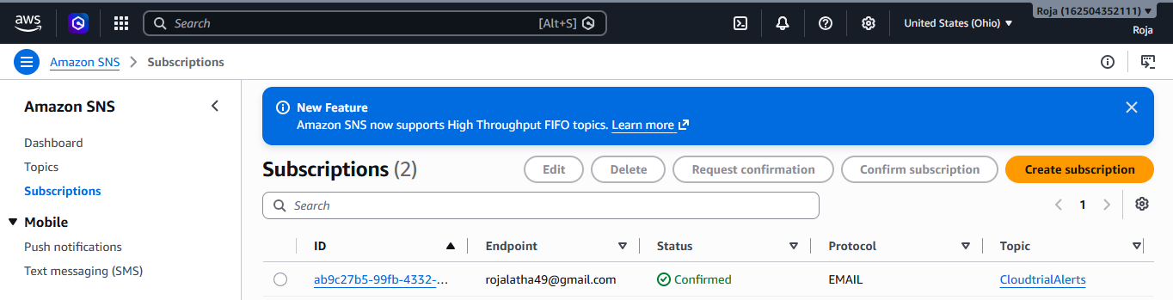

Step 3: Create the CloudWatch Alarm
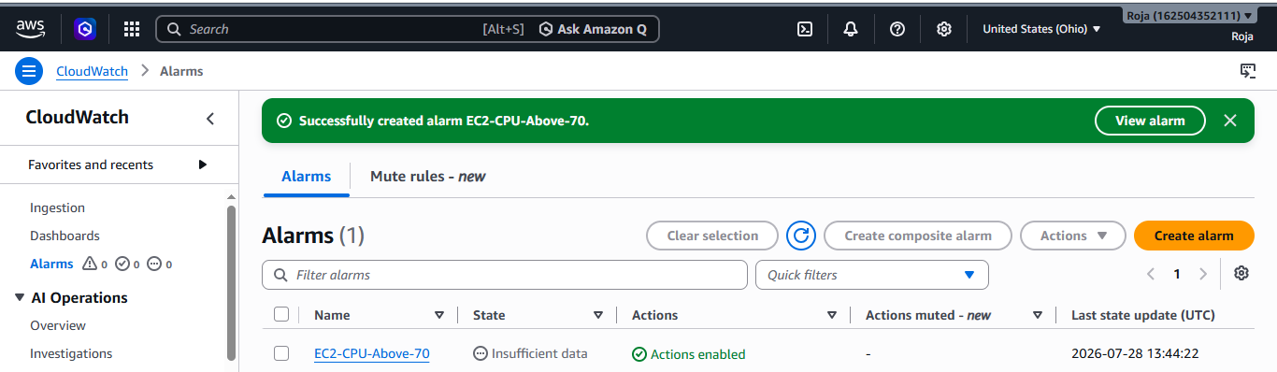

Step 4: Test the Alarm

Connect to instance and check Cpu utilization using top command.

Now go back to cloudwatch Alarm and see that the status which is in Ok will change to In Alarm state

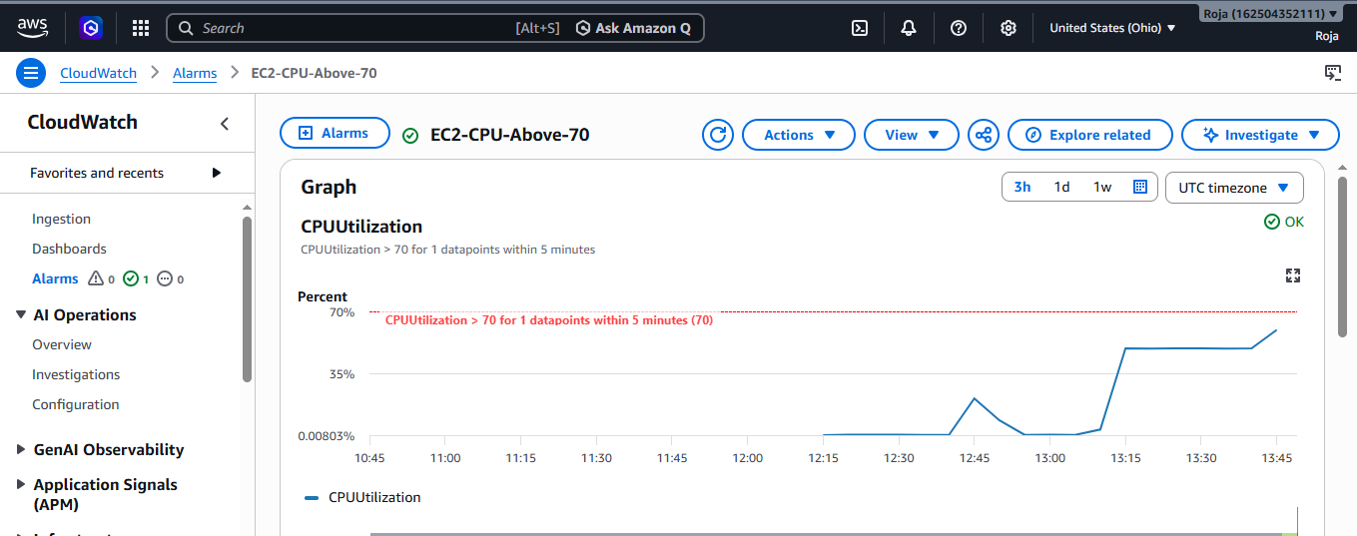

Status has changed to In Alarm state:

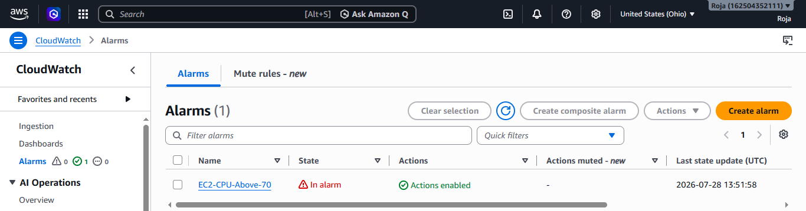

SNS should then send an email notification to your confirmed email address.

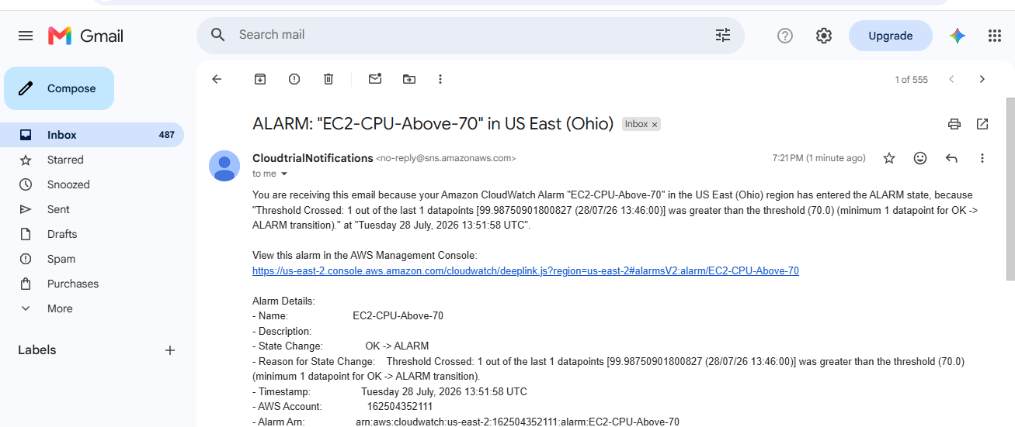
5. Create a Dashboard and monitor the Tomcat service whether it is running or not and send the alert.

Objective:
To create an Amazon CloudWatch Dashboard to monitor the status of the Apache Tomcat service running on an EC2 instance and configure an email alert when the Tomcat service stops.

Prerequisites
- AWS account
- Running Linux EC2 instance
- Apache Tomcat installed
- Tomcat configured as a systemd service named tomcat
- AWS CLI installed on the EC2 instance
- AWS CLI configured or EC2 attached IAM role with permission to publish CloudWatch metrics
- SNS topic and confirmed email subscription
Step 1: Verify Tomcat Service
Connect to your EC2 instance and check the status of Tomcat.
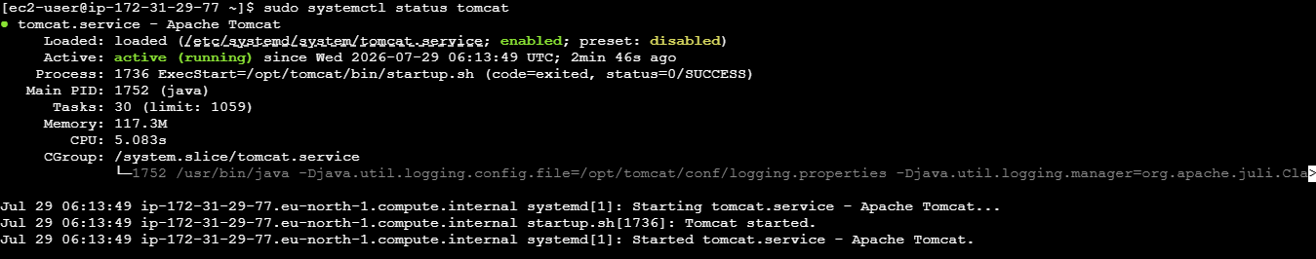

Step 2: Verify AWS CLI

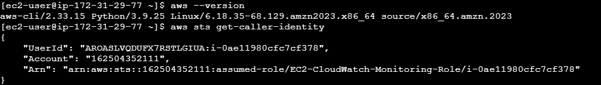

Step 3: Give EC2 Permission to Publish Metrics

Create an IAM Role:

IAM → Roles → Create role

For trusted entity type select AWS service and use case select EC2

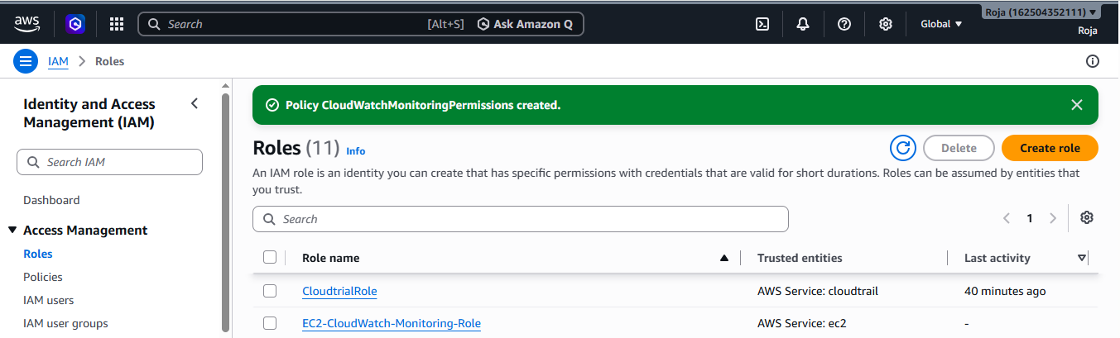

Attach CloudWatch Permission Attach the Role to Your EC2 Instance

Search for CloudWatchAgentServerPolicy and select it.

Give a name to your role and then click on create a role.
Now open EC2 instance, go to Actions → Security → Modify IAM role, select the role and attach it.

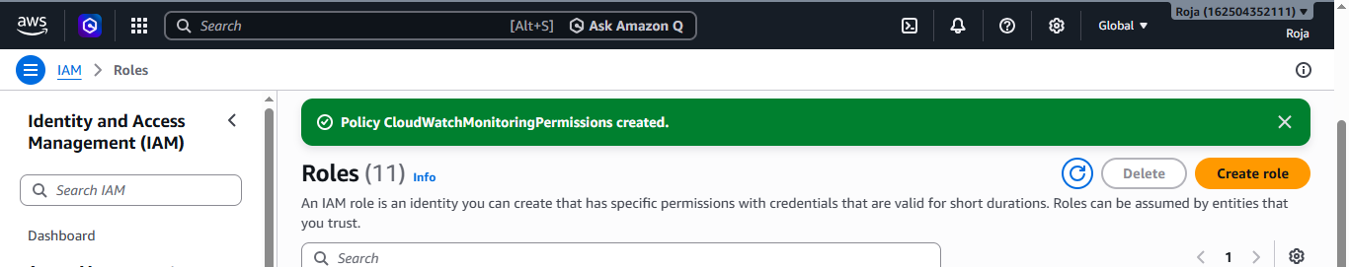

Step 4: Verify the Role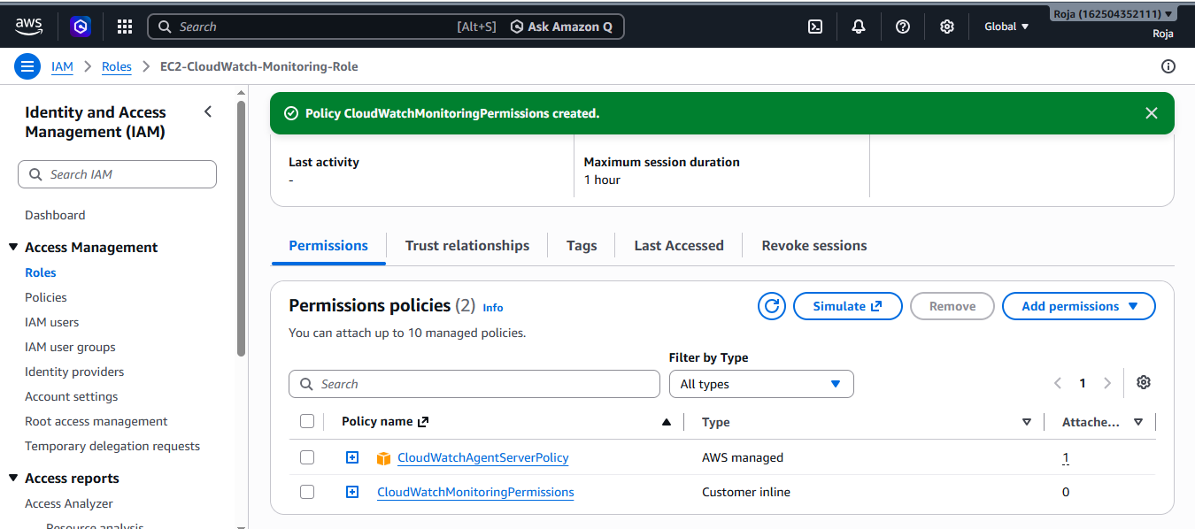

Go to EC2 instance and verify the role
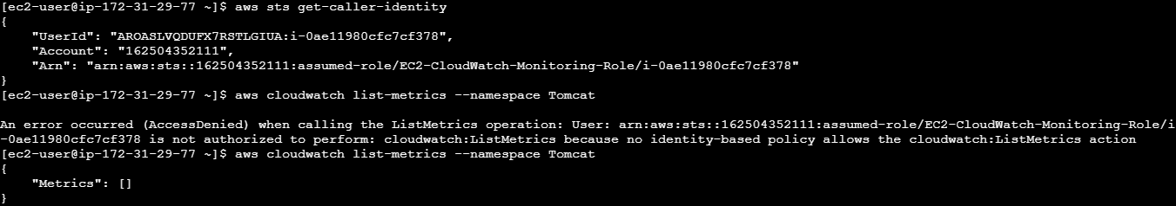

Step 4: Create a Tomcat Monitoring Script
Create a script using sudo vi editor and add a script
Give execute permissions and run the script

Step 5 :Verify Custom Metric in CloudWatch

Open cloudwatch→Metrics→Classic metrics and see the custom/Tomcat.
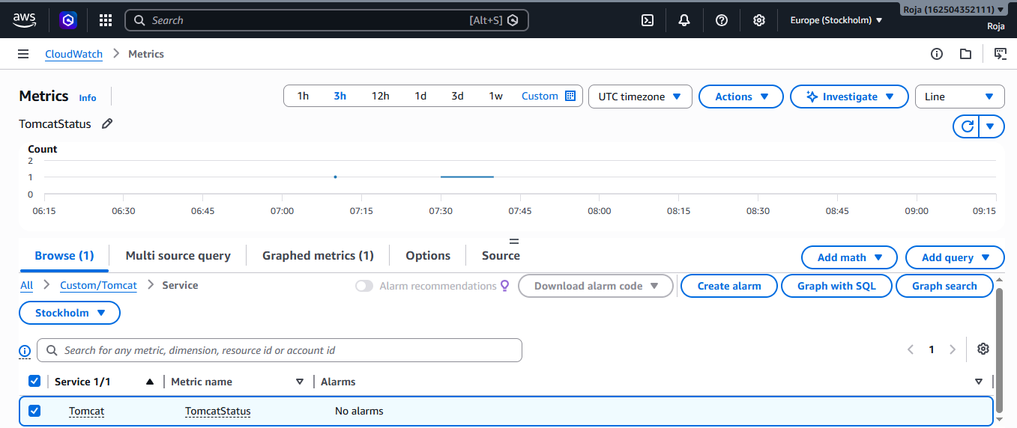
Step 6: Create SNS Topic & Create an Email Subscription

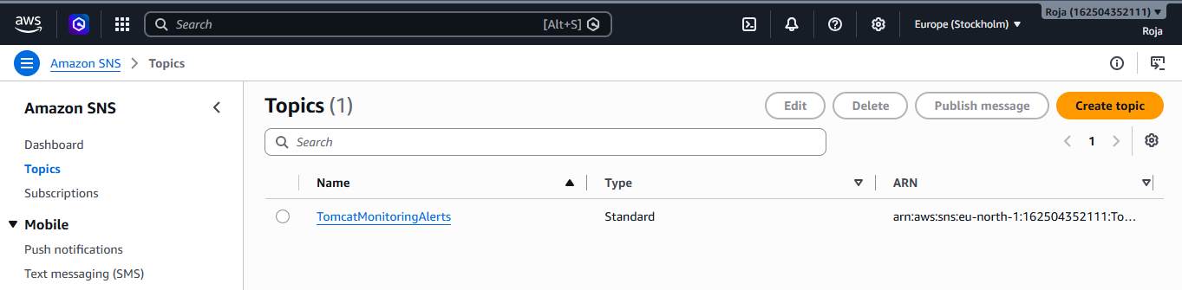

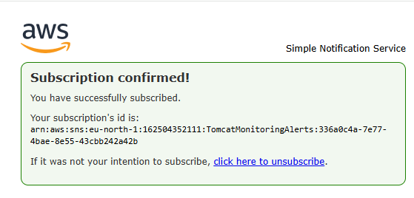

Step 7: Create an Alarm:

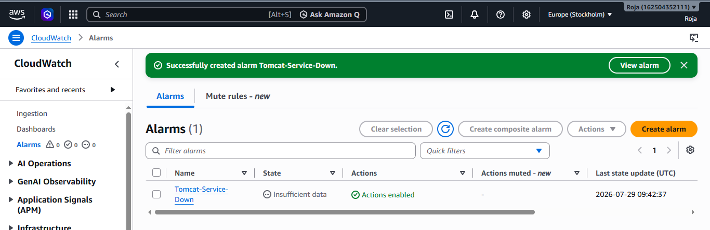

Step 8: Create CloudWatch Dashboard

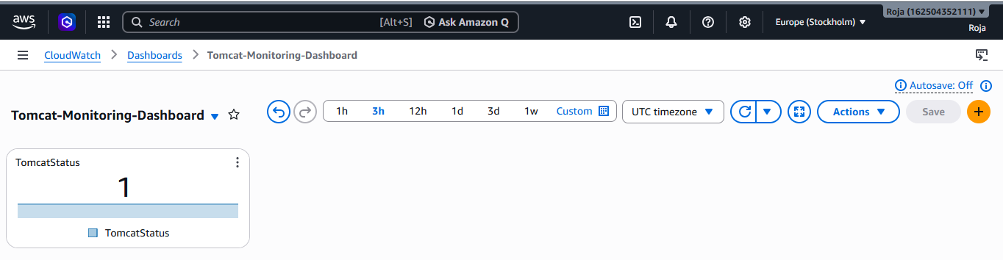

Step 9: Add Alarm to Dashboard:
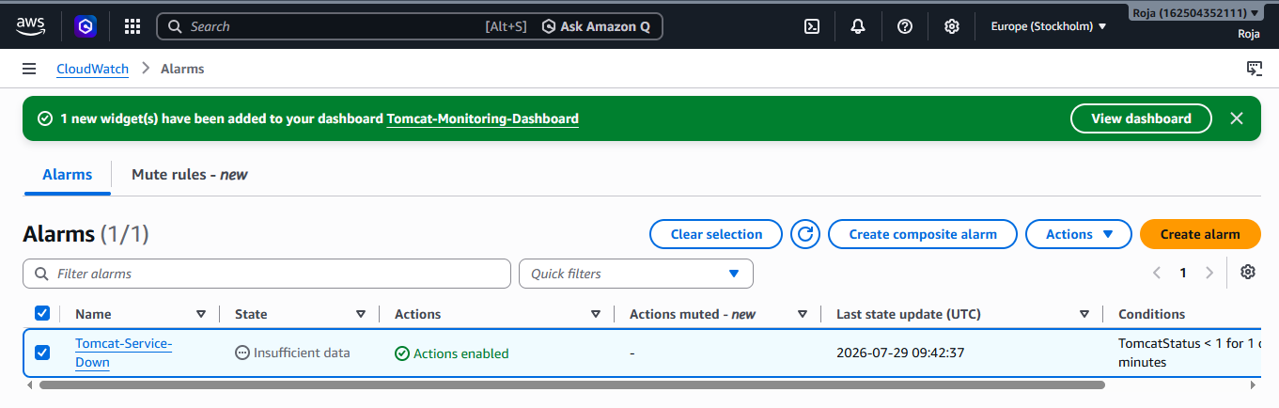

Step 10: Test the Monitoring
Stop the tomcat in EC2 and check the metric in the dashboard turns to zero.

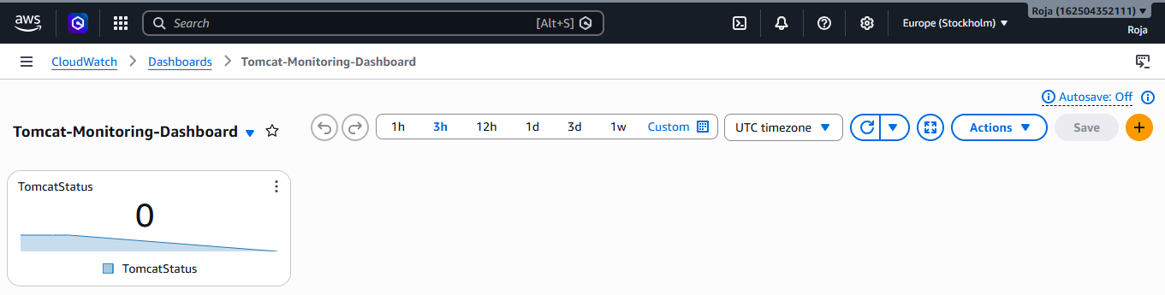

Alarm also changes to status in Alarm and you should receive an email from SNS
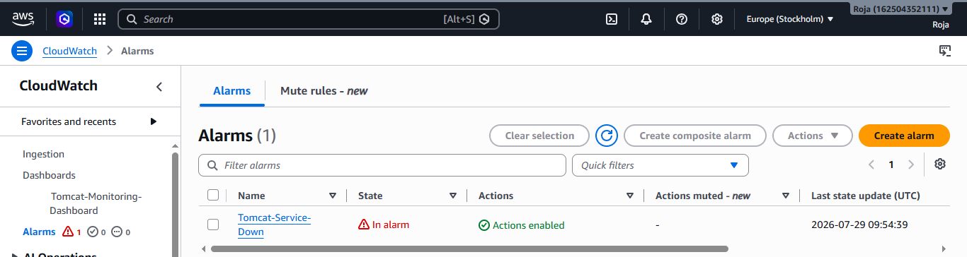

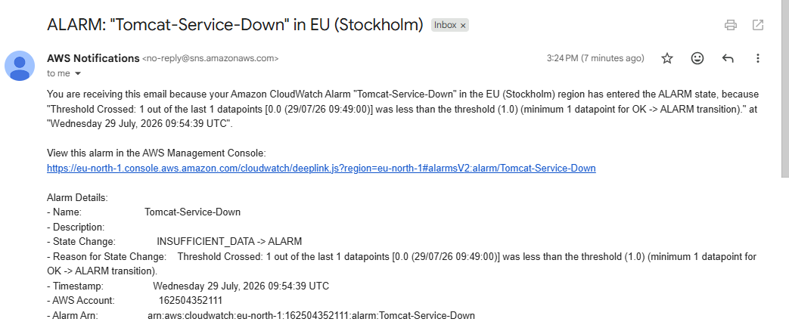

6. Create a Dashboard and monitor the Nginx service to send the alert if Nginx is not running

Objective:
To create an Amazon CloudWatch Dashboard to monitor the Nginx service running on an EC2 instance and configure an alert through Amazon SNS when Nginx is not running.
Prerequisites:
- An AWS EC2 instance.
- Nginx installed on the EC2 instance.
- Nginx configured as a systemd service.
- IAM role attached to EC2 with permission to publish CloudWatch custom metrics.
- An SNS topic with a confirmed email subscription.
Step 1 : Verify Nginx Installation
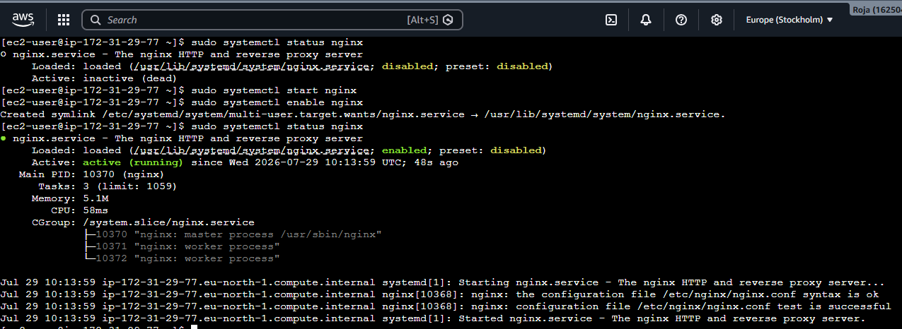
Step 2: Create Nginx Monitoring Script
Step 3: Give EC2 Permission to Publish CloudWatch Metrics

Create an IAM Role:

IAM → Roles → Create role

For trusted entity type select AWS service and use case select EC2

Step 4 : Attach CloudWatch Permission Attach the Role to Your EC2 Instance

Search for CloudWatchAgentServerPolicy and select it.

Give a name to your role and then click on create a role.
Now open EC2 instance, go to Actions → Security → Modify IAM role, select the role and attach it.

Step 5: Test the Monitoring Script

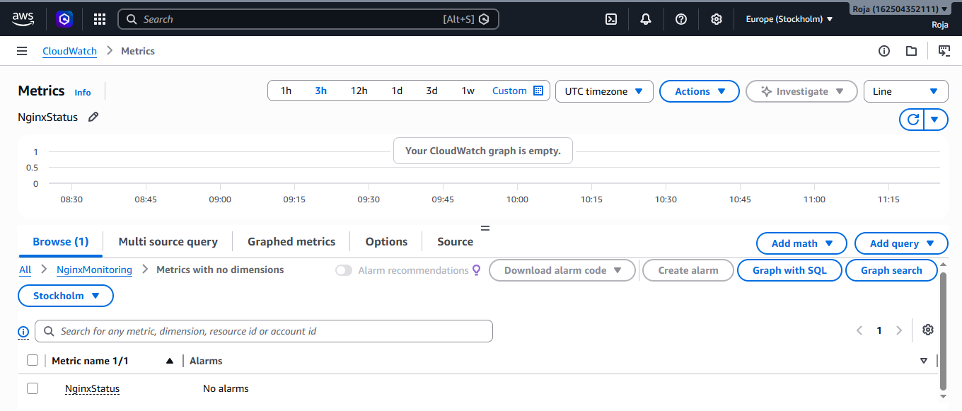

Step 6:Create SNS Topic

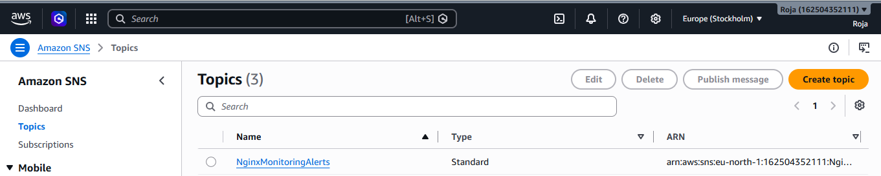

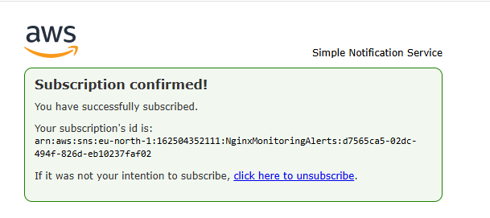
Step 7 : Create an Alarm:
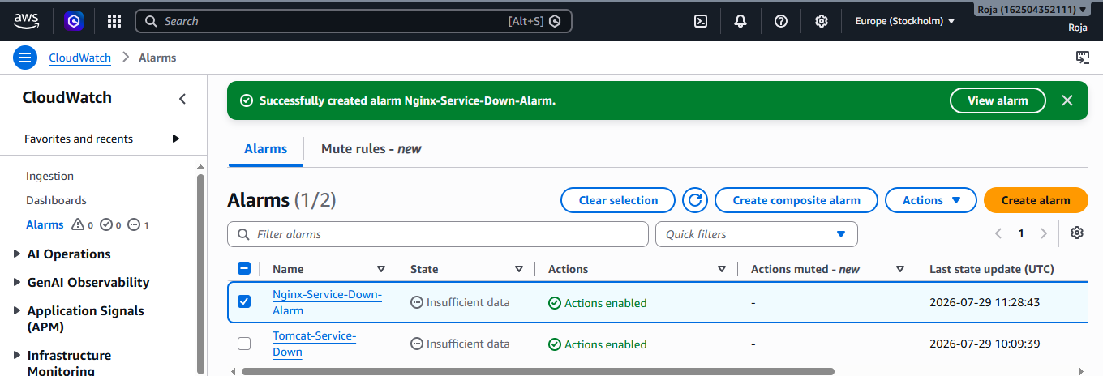
Step 8: Create CloudWatch Dashboard:
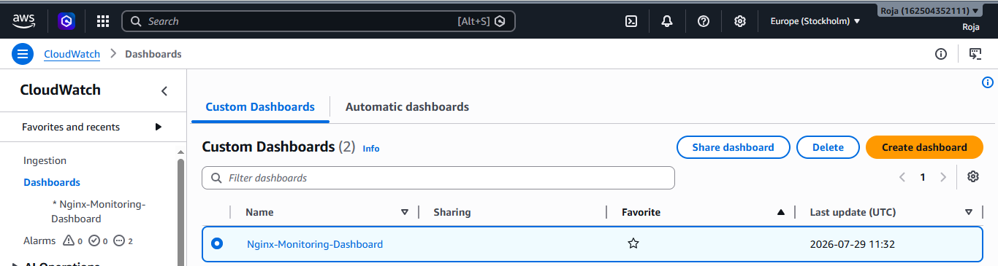

Step 9 : Add Nginx Alarm to Dashboard
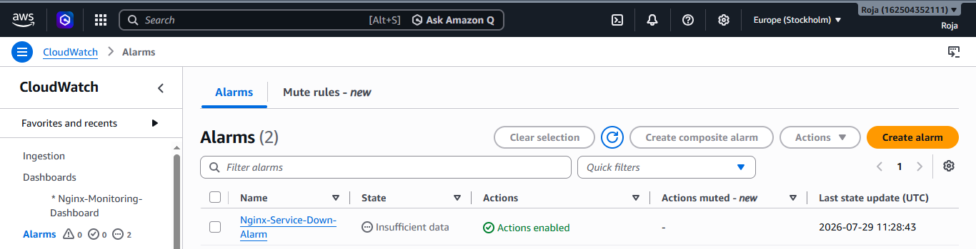

Step:10 Test the Alert
Start Nginx in EC2 and check the metric in the dashboard displays 1.
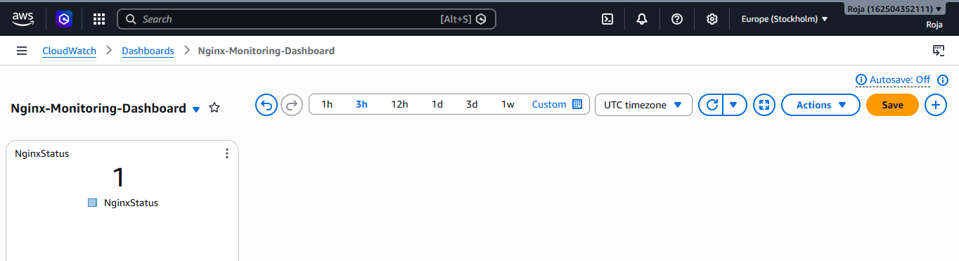
Now stop Nginx in Ec2 and check the metrics in dashboard, it displays zero
